**IMO 1969**

Problems of the 11th [IMO](https://www.artofproblemsolving.com/wiki/index.php?title=IMO) 1969 in Romania.

**Problem 1**

Prove that there are infinitely many natural numbers $a$ with the following property: the number $z = n^4 + a$ is not prime for any natural number$n$.

**Problem 2**

Let $a_1, a_2, \cdots, a_n$ be real constants, $x$ a real variable, andGiven that $f(x_1) = f(x_2) = 0$, prove that $x_2 - x_1 = m\pi$ for some integer $m$.

**Problem 3**

For each value of $k = 1, 2, 3, 4, 5$, find necessary and sufficient conditions on the number $a > 0$ so that there exists a tetrahedron with k edges of length $a$, and the remaining $6 - k$ edges of length 1.

**Problem 4**

A semicircular arc $\gamma$ is drawn on $AB$ as diameter. $C$ is a point on $\gamma$ other than $A$ and $B$, and $D$ is the foot of the perpendicular from $C$ to $AB$. We consider three circles, $\gamma_1, \gamma_2, \gamma_3$, all tangent to the line $AB$. Of these, $\gamma_1$ is inscribed in $\Delta ABC$, while $\gamma_2$ and $\gamma_3$ are both tangent to$CD$ and to $\gamma$, one on each side of $CD$. Prove that $\gamma_1$, $\gamma_2$ and $\gamma_3$ have a second tangent in common.

**Problem 5**

Given $n > 4$ points in the plane such that no three are collinear. Prove that there are at least $\tbinom{n - 3}{2}$ convex quadrilaterals whose vertices are four of the given points.

**Problem 6**

Prove that for all real numbers $x_1, x_2, y_1, y_2, z_1, z_2$, with $x_1 > 0, x_2 > 0, x_1y_1 - z_1^2 > 0, x_2y_2 - z_2^2 > 0$, the inequalityis satisfied. Give necessary and sufficient conditions for equality.

IMO 1969 Solutions

# **Problem 1**

The equation was$z = n^4 + a$ ,you can put $a = 4 m^4$ for all natural numbers m. So you will get $z = n^4 + 4 m^4 = n^4+4m^4 +4n^2 m^2 - 4n^2 m^2$ $z = (n^2+2 m^2)^2 - (2nm)^2 = (n^2+2 m^2 -2nm)(n^2+2 m^2 +2nm)$ so you get z is composite for all $a = 4 m^4$

# **Problem 2**

f is not identically zero, because

**f(-a1) = 1 + 1/2 cos(a2 - a1) + ... > 1 - 1/2 - 1/4 - ... - 1/2n-1 > 0.**

Using the expression for cos(x + y) we obtain

**f(x) = b cos x + c sin x,**

where **b = cos a1 + 1/2 cos a2 + ... + 1/2n-1 cos an,**

and c = - sin a1 - 1/2 sin a2 - ... - 1/2n-1 sin an. b and c are not both zero, since f is not identically zero, so f(x) = √(b2 + c2) cos(d + x), where cos d = b/√(b2 + c2), and sin d = c/√(b2 + c2). Hence the roots of f(x) = 0 are just mπ + π/2 - d.

# **Problem 3**

A plodding question. Take the tetrahedron to be ABCD. Take k = 1 and AB to have length a, the other edges length 1. Then we can hinge triangles ACD and BCD about CD to vary AB. The extreme values evidently occur with A, B, C, D coplanar. The least value, 0, when A coincides with B, and the greatest value v3, when A and B are on opposite sides of CD. We rule out the extreme values on the grounds that the tetrahedron is degenerate, thus obtaining 0 < a < v3. For k = 5, the same argument shows that 0 < 1 < v3 a, and hence a > 1/v3. For k = 2, there are two possible configurations: the sides length a adjacent, or not. Consider first the adjacent case. Take the sides length a to be AC and AD. As before, the two extreme cases gave A, B, C, D coplanar. If A and B are on opposite sides of CD, then a = v(2 - v3). If they are on the same side, then a = v(2 + v3). So this configuration allows any a satisfying v(2 - v3) < a < v(2 + v3).

The other configuration has AB = CD = a. One extreme case has a = 0. We can increase a until we reach the other extreme case with ADBC a square side 1, giving a = v2. So this configuration allows any a satisfying 0 < a < v2. Together, the two configurations allow any a satisfying: 0 < a < v(2 + v3).

This also solves the case k = 4, and allows any a satisfying: a > 1/v(2 + v3) = v(2 - v3). For k = 3, any value of a > 0 is allowed. For a = 1, we may take the edges length a to form a triangle. For a = 1 we may take a triangle with unit edges and the edges joining the vertices to the fourth vertex to have length a.

# **Problem 4**

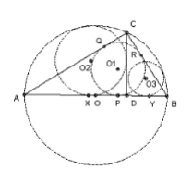

Let the three centers be O1, O2 and O3. We show that O1 is the midpoint of O2O3. In fact it is sufficient to show that O1 lies on O2O3, because then we can reflect the known tangent AB in the line O2O3.

As usual, let AB = c, BC = a, CA = b. Let the in-circle touch AB at P, AC at Q and BC at R. Then since angle ACB = 90, O1QCR is a square. Also AQ = AP and BP = BR, so r1 = b - AP, and r1 = a - BP = a - (c - AP). Adding: r1 = (a + b - c)/2, and AP = (b + c - a)/2.

Let the circle center O2 touch AB at X, and the circle center O3 touch AB at Y. Let O be the midpoint of AB. Now consider the right-angled triangle OXO2. Since the circle center O2 touches the semicircle, OO2 = c/2 - r2. OX = OD + DX = (c/2 - AD) + r2. Also, by similar triangles, AD = b2/c. So, using Pythagoras: (c/2 - r2)2 = r22 + (c/2 - b2/c + r2)2. Multiplying out and rearranging: r22 - 2r2(c - b2/c) - (b2 - b4/c2). But ABC is right-angled, so c2 = a2 + b2, and hence c - b2/c = a2/c and b2 - b4/c2 = a2b2/c2. So r22 + 2r2 a2/c - a2b2/c2 = 0, which has roots r2 = a - a2/c (positive) and - a + a2/c (negative). So r2 = a - a2/c. Similarly, r3 = b - b2/c. So O2X + O3Y = XY = r2 + r3 = a + b - c = 2 r1.

XP = AP - AX = AP - (AD - DX) = (b + c - a)/2 - (b2/c - r2) = (b + c - a)/2 - (c - a) = (a + b - c)/2 = r1. We now have all we need: XP = PY = PO1, and XO2 + YO3 = 2 PO1.

# **Problem 5**

(n-3)(n-4)/2 is a poor lower bound.

Observe first that any 5 points include 4 forming a convex quadrilateral. For take the convex hull. If it consists of more than 3 points, we are done. If not, it must consist of 3 points, A, B and C, with the other 2 points, D and E, inside the triangle ABC. Two vertices of the triangle must lie on the same side of the line DE and they form convex quadrilateral with D and E.

Given n points, we can choose 5 in n(n-1)(n-2)(n-3)(n-4)/120 different ways. Each choice gives us a convex quadrilateral, but any given convex quadrilateral may arise from n-4 different sets of 5 points, so we have at least n(n-1)(n-2)(n-3)/120 different convex quadrilaterals. We now show that n(n-1)(n-2)(n-3)/120 = (n-3)(n-4)/2 for all n = 5.

We wish to prove that n(n-1)(n-2) = 60(n-4), or n(n-1)(n-2) - 60(n-4) = 0. Trial shows equality for n = 5 and 6, so we can factorize and get (n-5)(n-6)(n+8), which is clearly at least 0 for n at least 5.

# **Problem 6**

Let a1 = x1y1 - z12 and a2 = x2y2 - z22. We apply the arithmetic/geometric mean result 3 times:

(1) to a12, a22, giving 2a1a2 <= a12 + a22;

(2) to a1, a2, giving Ö(a1a2) <= (a1 + a2)/2;

(3) to a1y2/y1, a2y1/y2, giving v(a1a2) <= (a1y2/y1 + a2y1/y2)/2;

We also use (z1/y1 - z2/y2)2 >= 0. Now x1y1 > z12 >= 0, and x1 > 0, so y1 > 0. Similarly, y2 > 0. So:

(4) y1y2(z1/y1 - z2/y2)2 >= 0, and hence z12y2/y1 + z22y1/y2 >= 2z1z2.

Using (3) and (4) gives

2v(a1a2) <= (x1y2 + x2y1) - (z12y2/y1 + z22y1/y2) <= (x1y2 + x2y1 - 2z1z2).

Multiplying by (2) gives: 4a1a2 <= (a1 + a2)(x1y2 + x2y1 - 2z1z2).

Adding (1) and 2a1a2 gives: 8a1a2 <= (a1 + a2)2 + (a1 + a2)(x1y2 + x2y1 - 2z1z2) = a(a1 + a2), where a = (x1 + x2)(y1 + y2) - (z1 + z2)2. Dividing by a1a2a gives the required inequality.

Equality requires a1 = a2 from (1), y1 = y2 from (2), z1 = z2 from (3), and hence x1 = x2. Conversely, it is easy to see that these conditions are sufficient for equality.



**IMO 1970**

Problems of the 12th [IMO](https://www.artofproblemsolving.com/wiki/index.php?title=IMO) 1970 Hungary.

## Day 1

### Problem 1

Let $\displaystyle M$ be a point on the side $\displaystyle AB$ of $\displaystyle \triangle ABC$. Let $\displaystyle r_1, r_2$, and $\displaystyle r$ be the inscribed circles of triangles $\displaystyle AMC, BMC$, and $\displaystyle ABC$. Let $\displaystyle q_1, q_2$, and$\displaystyle q$ be the radii of the exscribed circles of the same triangles that lie in the angle $\displaystyle ACB$. Prove that

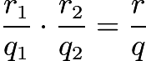.

### Problem 2

Let $\displaystyle a, b$, and $\displaystyle n$ be integers greater than 1, and let $\displaystyle a$ and $\displaystyle b$ be the bases of two number systems. $\displaystyle A_{n-1}$ and $\displaystyle A_{n}$ are numbers in the system with base $\displaystyle a$ and $\displaystyle B_{n-1}$ and $\displaystyle B_{n}$ are numbers in the system with base $\displaystyle b$; these are related as follows:

$\displaystyle A_{n} = x_{n}x_{n-1}\cdots x_{0}, A_{n-1} = x_{n-1}x_{n-2}\cdots x_{0}$,

$\displaystyle B_{n} = x_{n}x_{n-1}\cdots x_{0}, B_{n-1} = x_{n-1}x_{n-2}\cdots x_{0}$,

$\displaystyle x_{n} \neq 0, x_{n-1} \neq 0$.

Prove:

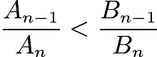 if and only if $\displaystyle a > b$.

### Problem 3

The real numbers $\displaystyle a_0, a_1, \ldots, a_n, \ldots$ satisfy the condition:

$\displaystyle 1 = a_{0} \leq a_{1} \leq \cdots \leq a_{n} \leq \cdots$.

The numbers $\displaystyle b_{1}, b_{2}, \ldots, b_n, \ldots$ are defined by

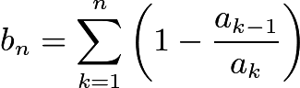

(a) Prove that $\displaystyle 0 \leq b_n < 2$ for all $\displaystyle n$.

(b) given $\displaystyle c$ with $0 \leq c < 2$, prove that there exist numbers $a_0, a_1, \ldots$ with the above properties such that $\displaystyle b_n > c$ for large enough $\displaystyle n$.

## Day 2

### Problem 4

Find the set of all positive integers $\displaystyle n$ with the property that the set $\displaystyle \{ n, n+1, n+2, n+3, n+4, n+5 \}$ can be partitioned into two sets such that the product of the numbers in one set equals the product of the numbers in the other set.

### Problem 5

In the tetrahedron $\displaystyle ABCD$, angle $\displaystyle BDC$ is a right angle. Suppose that the foot $\displaystyle H$ of the perpendicular from $\displaystyle D$ to the plane $\displaystyle ABC$ in the tetrahedron is the intersection of the altitudes of $\displaystyle \triangle ABC$. Prove that

$\displaystyle ( AB+BC+CA )^2 \leq 6( AD^2 + BD^2 + CD^2 )$.

For what tetrahedra does equality hold?

### Problem 6

In a plane there are $100$ points, no three of which are collinear. Consider all possible triangles having these point as vertices. Prove that no more than $70 \%$ of these triangles are acute-angled.



IMO 1970 Solutions

**Problem 1**

## Solution 1

We use the conventional triangle notations.

Let $I$ be the incenter of $ABC$, and let $I_{c}$ be its excenter to side $c$. We observe that

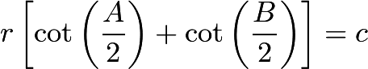,

and likewise,

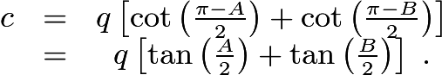

Simplifying the quotient of these expressions, we obtain the result

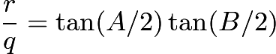.

Thus we wish to prove that

$\tan (A/2) \tan (B/2) = \tan (A/2) \tan (AMC/2) \tan (B/2) \tan (CMB/2)$.

But this follows from the fact that the angles $AMC$ and $CBM$ are supplementary.

## Solution 2

By similar triangles and the fact that both centers lie on the angle bisector of $\angle{C}$, we have 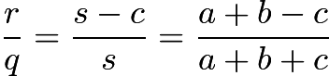, where $s$ is the semi-perimeter of $ABC$. Let $ABC$ have sides $a, b, c$, and let $AM = c_1, MB = c_2, MC = d$. After simple computations, we see that the condition, whose equivalent form is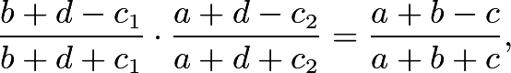is also equivalent to Stewart's Theorem\[d^2 c + c_1 c_2 c = a^2 c_1 + b^2 c_2.\]

**Problem 2**

Suppose $a>b$. Then for all integers $0 \le k \le n$, $x_n x_k a^n b^k \ge x_n x_k b^n a^k$, with equality only when $k=n$ or $x_k = 0$. (In particular, we have strict inequality for $k=n-1$.) In summation, this becomes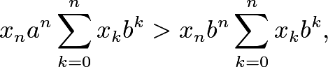or\[x_n a^n \cdot B_n > x_n b^n \cdot A_n,\]which is equivalent to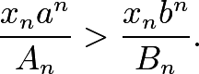This implies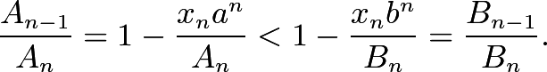On the other hand, if $a=b$, then evidently $A_{n-1}/A_n = B_{n-1}/B_n$, and if $a < b$, then by what we have just shown, $A_{n-1}/A_n > B_{n-1}/B_n$. Hence $A_{n-1}/A_n < B_{n-1}/B_n$ if and only if $a>b$, as desired. $\blacksquare$

**Problem 3**

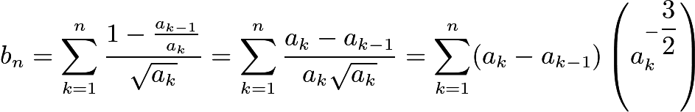

Let $X_k$ be the rectangle with the verticies: $(a_{k-1},0)$; $(a_{k},0)$; 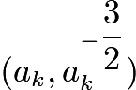; 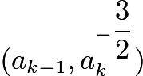.

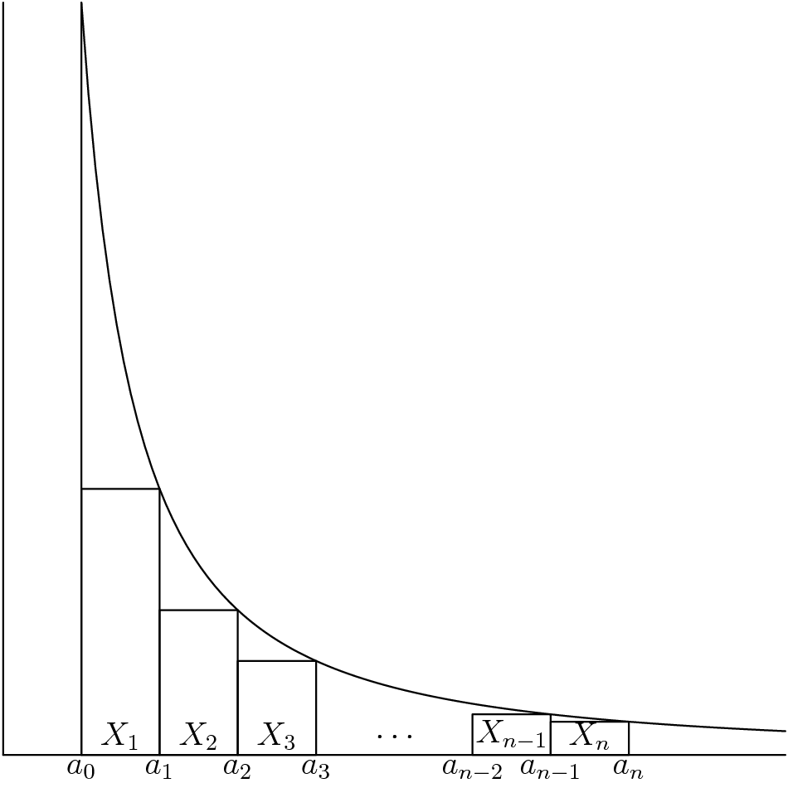

For all $k \in \mathbb{N}$, the area of $X_k$ is 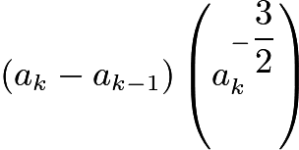. Therefore, 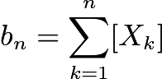

For all sequences $\{ a_k \}$ and all $k \in \mathbb{N}$, $X_k$ lies above the $x$-axis, below the curve 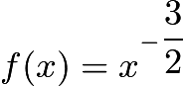, and in between the lines $x = 1$ and $x = a_n$, Also, all such rectangles are disjoint.

Thus, 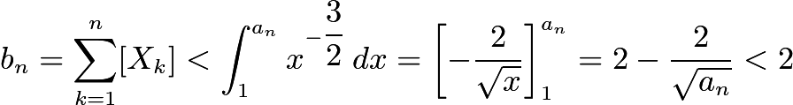 as desired.

By choosing $a_k = 1 + k (\Delta x)$, where $\Delta x > 0$, $b_n$ is a [Riemann sum](https://www.artofproblemsolving.com/wiki/index.php?title=Riemann_sum) for 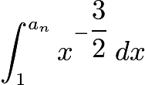. Thus, 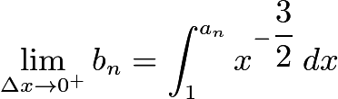.

Therefore, 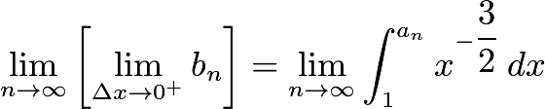 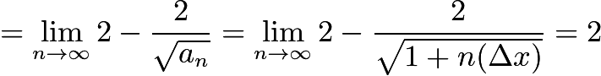.

So for any $c \in [0,2)$, we can always select a small enough $\Delta x > 0$ to form a sequence $\{ a_n \}$satisfying the above properties such that $b_n > c$ for large enough $n$ as desired.

**Problem 4**

## Solution 1

The only primes dividing numbers in the set can be 2, 3 or 5, because if any larger prime was a factor, then it would only divide one number in the set and hence only one product. Three of the numbers must be odd. At most one of the odd numbers can be a multiple of 3 and at most one can be a multiple of 5. The other odd number cannot have any prime factors. The only such number is 1, so the set must be $\{ 1, 2, 3, 4, 5, 6 \}$, but that does not work because only one of the numbers is a multiple of 5. So there are no such sets.

## Solution 2

As in the previous solution, none of the six consecutive numbers can be multiples of $7$. This means that together, they take on the values $\{ 1, 2, 3, 4, 5, 6, \} \mod 7$. The product of all the numbers in this set, then, is $-1 \mod 7$, by [Wilson's Theorem](https://www.artofproblemsolving.com/wiki/index.php?title=Wilson%27s_Theorem). However, $-1$ is not a[quadratic residue](https://www.artofproblemsolving.com/wiki/index.php?title=Quadratic_residue) $\mod 7$, which means that we cannot partition the original set into two sets of equal product. Thus, no such $n$ exist.

**Problem 5**

Let us show first that angles $ADB$ and $ADC$ are also right. Let $H$ be the intersection of the altitudes of $ABC$ and let $CH$ meet $AB$ at $X$. Planes $CED$ and $ABC$ are perpendicular and $AB$ is perpendicular to the line of intersection $CE$. Hence $AB$ is perpendicular to the plane $CDE$ and hence to $ED$. So $BD^2 = DE^2 + BE^2.$ Also $CB^2 = CE^2 + BE^2.$ Therefore $CB^2 - BD^2 = CE^2 - DE^2.$ But $CB^2 - BD^2 = CD^2,$ so $CE^2 = CD^2 + DE^2$, so angle $CDE = 90^{\circ}$. But angle $CDB = 90^{\circ}$, so $CD$ is perpendicular to the plane $DAB$, and hence angle $CDA$ = $90^{\circ}$. Similarly, angle $ADB = 90^{\circ}$. Hence $AB^2 + BC^2 + CA^2 = 2(DA^2 + DB^2 + DC^2)$. But now we are done, because Cauchy's inequality gives $(AB + BC + CA)^2 = 3(AB^2 + BC^2 + CA^2).$ We have equality if and only if we have equality in Cauchy's inequality, which means $AB = BC = CA.$

**Problem 6**

At most 3 of the triangles formed by 4 points can be acute. It follows that at most 7 out of the 10 triangles formed by any 5 points can be acute. For given 10 points, the maximum no. of acute triangles is: the no. of subsets of 4 points x 3/the no. of subsets of 4 points containing 3 given points. The total no. of triangles is the same expression with the first 3 replaced by 4. Hence at most 3/4 of the 10, or 7.5, can be acute, and hence at most 7 can be acute. The same argument now extends the result to 100 points. The maximum number of acute triangles formed by 100 points is: the no. of subsets of 5 points x 7/the no. of subsets of 5 points containing 3 given points. The total no. of triangles is the same expression with 7 replaced by 10. Hence at most 7/10 of the triangles are acute.

**IMO 1971**

Problems of the 13th [IMO](https://www.artofproblemsolving.com/wiki/index.php?title=IMO) 1971 in Czechoslovakia.

## Problem 1

Prove that the following assertion is true for $n = 3$ and $n = 5$, and that it is false for every other natural number $n > 2$:

If $a_1, a_2, \cdots, a_n$ are arbitrary real numbers, then\[(a_1 - a_2)(a_1 - a_3) \cdots (a_1 - a_n) + (a_2 - a_1)(a_2 - a_3) \cdots (a_2 - a_n) \\ + \cdots + (a_n - a_1)(a_n - a_2) \cdots (a_n - a_{n - 1}) \geq 0\]

## \[(a_1 - a_2)(a_1 - a_3) \cdots (a_1 - a_n) + (a_2 - a_1)(a_2 - a_3) \cdots (a_2 - a_n) \\ + \cdots + (a_n - a_1)(a_n - a_2) \cdots (a_n - a_{n - 1}) \geq 0\]

## Problem 2

Consider a convex polyhedron $P_1$ with nine vertices $A_1, A_2, \cdots, A_9$; let $P_i$ be the polyhedron obtained from $P_1$ by a translation that moves vertex $A_1$ to $A_i (i = 2, 3, \cdots, 9)$. Prove that at least two of the polyhedra $P_1, P_2, \cdots, P_9$ have an interior point in common.

## Problem 3

Prove that the set of integers of the form $2^k - 3 (k = 2, 3, \cdots)$ contains an infinite subset in which every two members are relatively prime.

## Problem 4

All the faces of tetrahedron $ABCD$ are acute-angled triangles. We consider all closed polygonal paths of the form $XYZTX$ defined as follows: $X$ is a point on edge $AB$ distinct from $A$ and $B$; similarly, $Y, Z, T$ are interior points of edges $BC, CD, DA$, respectively. Prove:

(a) If $\angle DAB + \angle BCD \neq \angle CDA + \angle ABC$, then among the polygonal paths, there is none of minimal length.

(b) If $\angle DAB + \angle BCD = \angle CDA + \angle ABC$, then there are infinitely many shortest polygonal paths, their common length being $2AC \sin(\alpha / 2)$, where $\alpha = \angle BAC + \angle CAD + \angle DAB$.

## Problem 5

Prove that for every natural number $m$, there exists a finite set $S$ of points in a plane with the following property: For every point $A$ in $S$, there are exactly $m$ points in $S$ which are at unit distance from $A$.

## Problem 6

Let $A = (a_{ij})(i, j = 1, 2, \cdots, n)$ be a square matrix whose elements are non-negative integers. Suppose that whenever an element $a_{ij} = 0$, the sum of the elements in the $i$th row and the $j$th column is $\geq n$. Prove that the sum of all the elements of the matrix is $\geq n^2 / 2$.



IMO 1971 Solutions

**Problem 1**

Let En = (a1 - a2)(a1 - a3) ... (a1 - an) + (a2 - a1)(a2 - a3) ... (a2 - an) + ... + (an - a1)(an - a2) ... (an - an-1).

Take a1 < 0, and the remaining ai = 0. Then En = a1n-1 < 0 for n even, so the proposition is false for even n.

Suppose n >= 7 and odd. Take any c > a > b, and let a1 = a, a2 = a3 = a4= b, and a5 = a6 = ... = an = c. Then En = (a - b)3(a - c)n-4 < 0. So the proposition is false for odd n >= 7.

Assume a1 >= a2 >= a3. Then in E3 the sum of the first two terms is non-negative, because (a1 - a3) >= (a2 - a3). The last term is also non-negative. Hence E3 >= 0, and the proposition is true for n = 3.

It remains to prove S5. Suppose a1 >= a2 >= a3 >= a4 >= a5. Then the sum of the first two terms in E5 is (a1 - a2){(a1 - a3)(a1 - a4)(a1 - a5) - (a2 - a3)(a2 - a4)(a2 - a5)} >= 0. The third term is non-negative (the first two factors are non-positive and the last two non-negative). The sum of the last two terms is: (a4 - a5){(a1 - a5)(a2 - a5)(a3 - a5) - (a1 - a4)(a2 - a4)(a3 - a4)} >= 0. Hence E5 >= 0.

**Problem 2**

The result is false for 8 vertices - for example, the cube. We get 8 cubes, with only faces in common, forming a cube 8 times as large.

This suggests a trick. Each Pi is contained in D, the polyhedron formed from P1 by doubling the scale. Take A1 as the origin and take the vertex Bi to have twice the coordinates of Ai. Given a point X inside P1, the midpoint of PiX must lie in P1 by convexity. Hence the point with doubled coordinates, which is obtained by adding the coordinates of Ai to the coordinates of X, lies in D. In other words every point of Pi lies in D. But the volume of D is 8 times the volume of P1, which is less than the sum of the volumes of P1, ... , P9.

**Problem 3**

We show how to enlarge a set of r such integers to a set of r+1. So suppose 2n1 - 3, ... , 2nr - 3 are all relatively prime. The idea is to find 2n - 1 divisible by m = (2n1 - 3) ... (2nr - 3), because then 2n - 3 must be relatively prime to all of the factors of m. At least two of 20, 21, ... , 2m must be congruent mod m. So suppose m1 > m2 and 2m1  2m2 (mod m), then we must have 2m1- m2 - 1  0 (mod m), since m is odd. So we may take nr+1 to be m1 - m2.

**Problem 4**

The key is to pretend the tetrahedron is made of cardboard, cut it along three edges and unfold it. Suppose we do this to get the hexagon CAC'BDB'. Now the path is a line joining Y on B'C to Y' on the opposite side BC' of the hexagon. Clearly this line must be straight for a minimal path. If B'C and BC' are parallel, then we can take Y anywhere on the side and the minimal path length is the expression given.

But if they are not parallel, then the minimal path will come from an extreme position. Suppose CC' < BB'. If the interior angle CAC' is less than 180, then the minimal path is obtained by taking Y at C. But this does not meet the requirement that Y be an interior point of the edge, so there is no minimal path in the permitted set. If the interior angle CAC' is greater than 180, then the minimal path is obtained by taking X and T at A. Again this is not permitted.

The problem therefore reduces to finding the condition for B'C and BC' to be parallel. This is evidently angles BCD + DCA + CAD + BAD + BAC + ACB = 360. But DCA + CAD = 180 - ADC, and BAC + ACB = 180 - ABC, so we obtain the condition given.

**Problem 5**

Take a1, a2, ... , am to be points a distance 1/2 from the origin O. Form the set of 2m points a1 a2  ... am. Given such a point, it is at unit distance from the m points with just one coefficient different. So we are home, provided that we can choose the ai to avoid any other pairs of points being at unit distance, and to avoid any degeneracy (where some of the 2m points coincide).

The distance between two points in the set is |c1a1 + c2a2 + ... + cmam|, where ci = 0, 2 or -2. So let us choose the ai inductively. Suppose we have already chosen up to m. The constraints on am+1 are that we do not have |c1a1 + c2a2 + ... + cmam + 2am+1| equal to 0 or 1 for any ci = 0, 2 or -2, apart from the trivial cases of all ci = 0. Each | | = 0 rules out a single point and each | | = 1 rules out a circle which intersects the circle radius 1/2 about the origin at 2 points and hence rules out two points. So the effect of the constraints is to rule out a finite number of points, whereas we have uncountably many to choose from.

**Problem 6**

Let x be the smallest row or column sum. If x >= n/2, then we are done, so assume x < n/2. Suppose it is a row. (If not, interchange rows and columns.) The number of non-zero elements in the row, y, must also satisfy y < n/2, since each non-zero element is at least 1. Now move across this row summing the columns. The y columns with a non-zero element have sum at least x (by the definition of x). The n - y columns with a zero have sum at least n - x. Hence the total sum is at least xy + (n - x)(n - y) = n2/2 + (n - 2x)(n - 2y)/2 > n2/2.

The result is evidently best possible, because we can fill the matrix alternately with zeros and ones (so that aij = 1 if i and j are both odd or both even, 0 otherwise). For n even, every row and column has n/2 1s, so the condition is certainly satisfied and the total sum is n2/2. For n odd, odd numbered rows have (n+1)/2 1s and even numbered one less. But the only zeros are in positions which have either the row or the column odd-numbered, so the sum in such cases is n as required. The total sum is n2/2 + 1/2. Alternatively, for n even, we could place n/2 down the main diagonal.